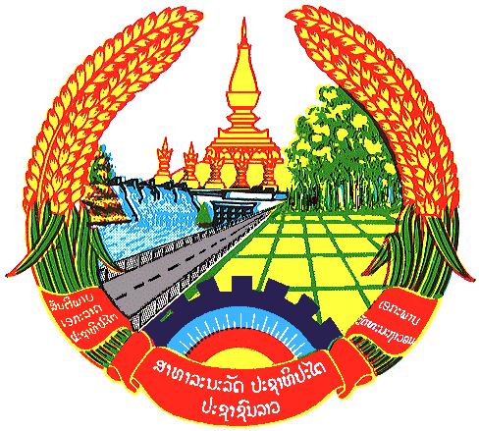

Statement by the delegation of the Lao PDR
At the 27th Session of UPR Working Group
Geneva, 1-12 May 2016
----------------

Review of India, 4 May 2017, at 14:30-18:00 hours

Mr. President,

The Lao delegation warmly welcomes the distinguished delegation of India to the 27th Session of the UPR Working Group and would like to thank for the comprehensive presentation of the National Report on the situation of human rights in the country.

My delegation commends India commitment to further promotion and protection human rights of its people by putting in place a robust set of social-economic policies to address the various needs of people including health, education, housing, poverty alleviation, women empowerment as well as food and social security.

We welcome measures under taken by the Government of India to ensure better protection and promotion rights for the person with disabilities by adopting new law on the rights of person with disabilities aims at facilitate greater access to public spaces, education, employment and health care. In this regards, my delegation recommends that India Continue its efforts to ensure that the universal health care scheme covers disadvantaged groups, including persons with disabilities and persons living in remote rural areas that still face obstacles in accessing basic health-care services.

Lao PDR appreciates efforts made by India to further enhance the rights to education by prioritises inclusive and quality education for all. Particularly, we commend commitment to further promote the children’s rights to education by continue implementation of a non-discriminatory and inclusive policies to quality of education for all children. We recommend that India Continue its efforts to ensure that all children have access to education at all levels and all categories.

We wish India every success in its Third Cycle of UPR review.

I thank you

